Topic 1 – Vector Matrix

Vector Matrix
A vector matrix is a matrix where each element is a vector rather than a scalar. This concept is useful in various machine learning applications, particularly in neural networks, where operations often involve sets of vectors.

Definition and Representation
A vector matrix can be represented as follows:
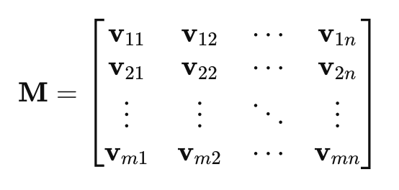
where each v_{ij}​ is a vector. For example, in the context of neural networks, v_{ij}​ could represent the weight vector connecting neuron i in one layer to neuron j in the next layer.

Example: Neural Networks
Neural networks, which are a cornerstone of deep learning, heavily rely on vectors and matrices for representing and processing data. Each layer of a neural network involves matrix operations that transform the input data into the output.

Problem Statement
Consider a simple neural network with one hidden layer to perform binary classification on a dataset with 3 input features.

Concrete Example
This example demonstrates how vector matrices are used in neural networks to represent weights and biases, and how they are manipulated through matrix operations to perform a forward pass. This process is central to training and using neural networks in machine learning for various tasks such as classification, regression, and more.

Let's set up a small neural network with:
- An input layer with 3 neurons (features).
- One hidden layer with 2 neurons.
- An output layer with 1 neuron (binary output).
We will use a vector matrix to represent the weights and biases, as well as the input data.
- Define the Network Structure:
  - Input layer: x (3 features)
  - Hidden layer: weights W₁​ (2 neurons, 3 features), biases b₁ (2 biases)
  - Output layer: weights W₂​ (1 neuron, 2 hidden neurons), bias b₂​ (1 bias)
- Initialize Weights and Biases:
Weights and biases are typically initialized randomly. For simplicity, let's use the following values:
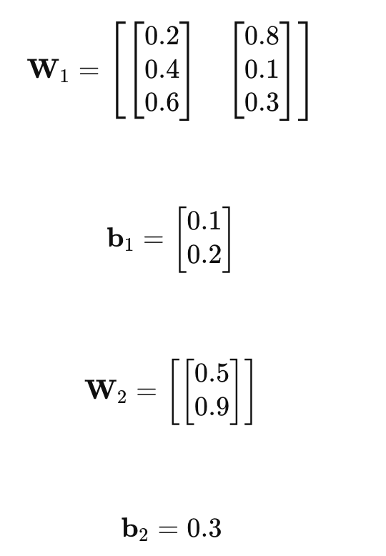
- Input Data:
Consider an input vector x:
​​ 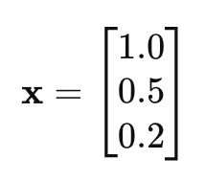

- Forward Pass:
Perform the forward pass to compute the output of the network.
- Compute the input to the hidden layer:
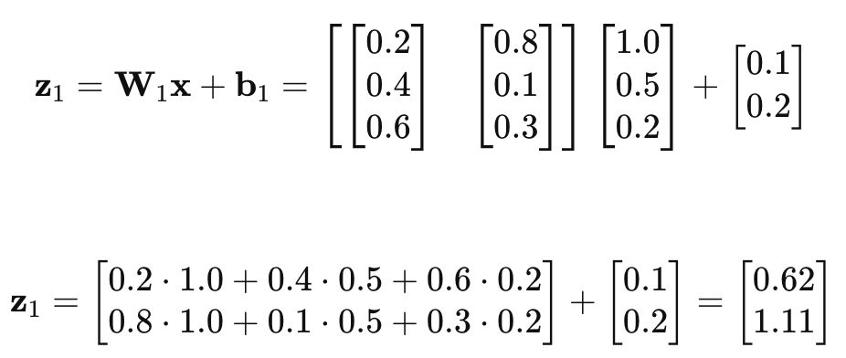
- Apply activation function (ReLU in this case):
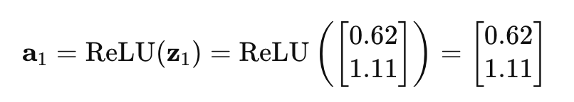
- Compute the input to the output layer:
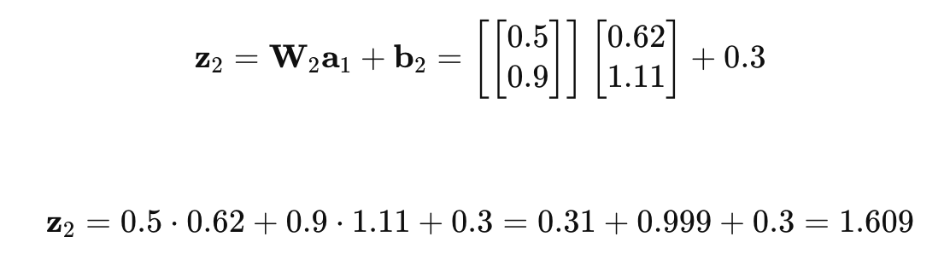
- Apply activation function (sigmoid in this case):
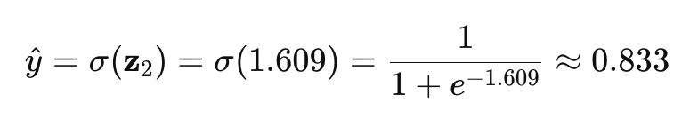
- Interpretation:
The output $\hat{y}≈0.833$represents the predicted probability that the input vector x belongs to the positive class.

